Driving with Diabetes
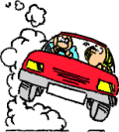
Before Driving:
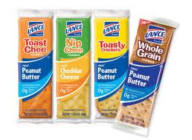
- Prepare your car:
  - Quick sugar (lifesavers, jelly beans)
  - Non-perishable snacks (arrowroots, crackers)
  - Carry your glucometer with you
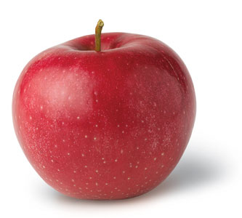

- If you have not tested or eaten in 4 hours then,
  - Test your blood sugar before driving
  - Test your blood sugar every 4 hours if driving long distances

- Your blood sugar must be “over 5.0 to drive”
  - This is directed by the Ministry of Transportation

- If your blood sugar is between 4.0 and 5.0, have something to eat
  - A piece of fruit OR a glass of milk

- If you have a low blood sugar (<4.0),
  - Treat the low blood sugar first:
    - Drink a small glass of juice or regular pop (3/4 cup)
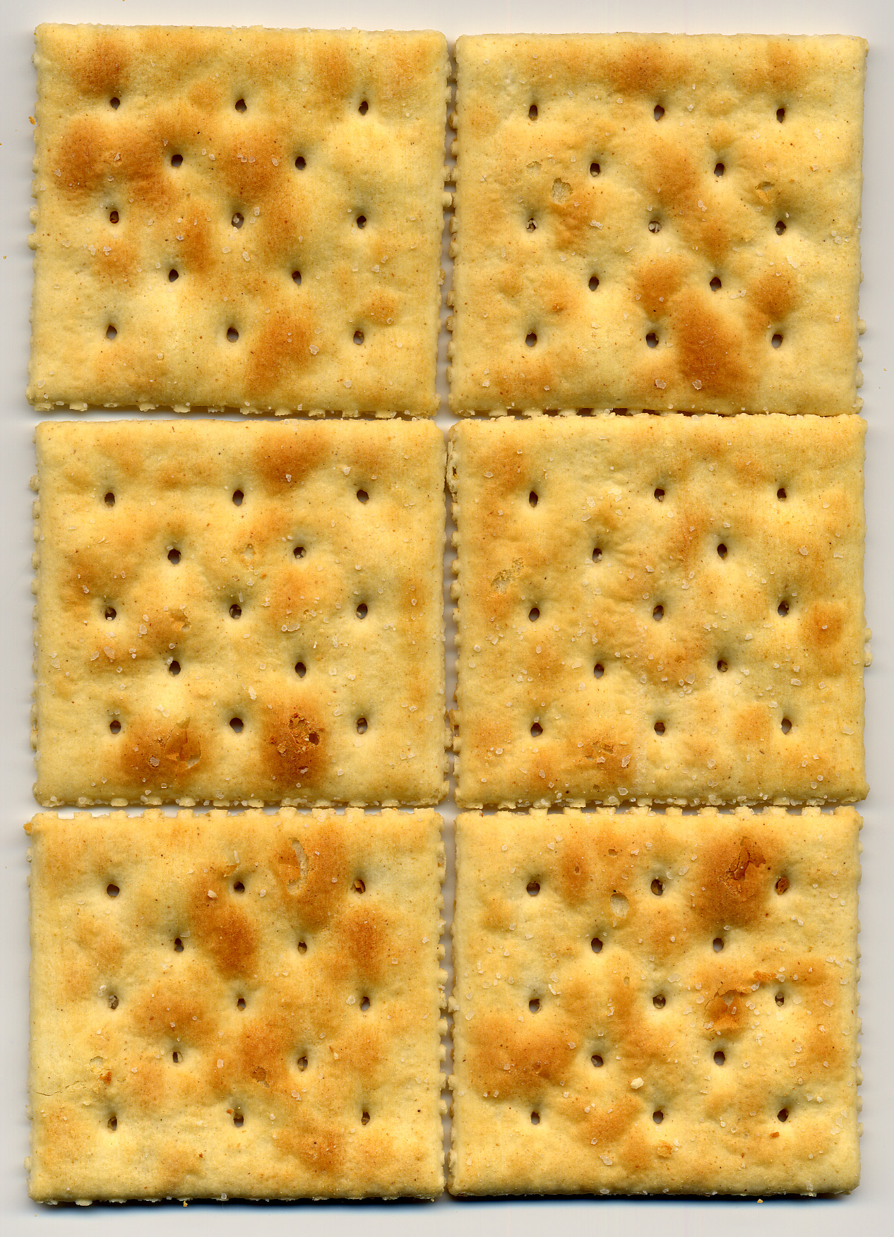
OR
    - Eat 6 lifesavers or 6 jelly beans

  - After that, eat your next meal or snack
    - 6 crackers with peanut butter
OR
    - A piece of fruit

If you have a low blood sugar, wait 1 hour before driving!

While driving:
FIVE
to DRIVE

If you think that your blood sugar is low (shaky, sweaty, confused)
- Immediately pull off the road
- Remove your keys from the ignition
- Test your blood sugar
- Treat the low blood sugar

Adapted from St. Joseph’s Health Care London
Jaclyn Strohl, MAN Student CFFM 2011

